1. Imagen ms-doctores

<https://hub.docker.com/layers/mcabrerac/ms-doctores/v2/images/sha256-958bbf8225fd644361e21fad8d76cedbba50b474b662451abd5a5e3142808976>

mcabrerac/ms-doctores:v2

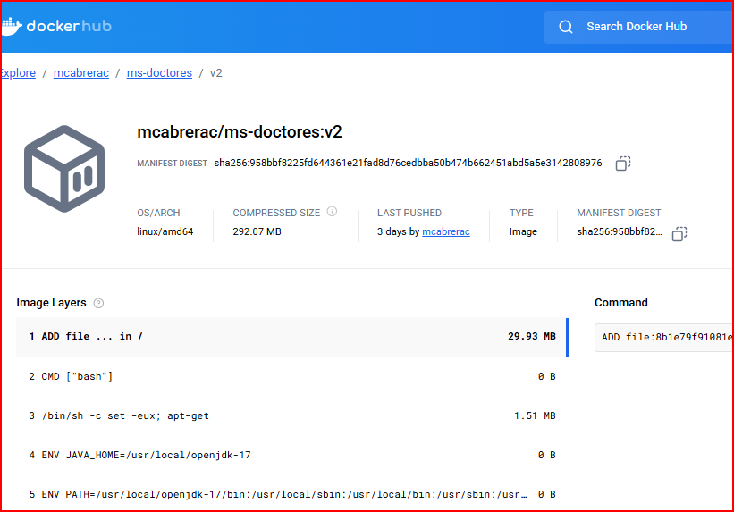

1. Imagen ms-usuarios

<https://hub.docker.com/layers/mcabrerac/ms-usuarios/v2/images/sha256-ad223cfa3c3e9f3db8abfebb5d2396b628a6298ebcd85cc3ad1d443bafce78ac>

mcabrerac/ms-usuarios:v2

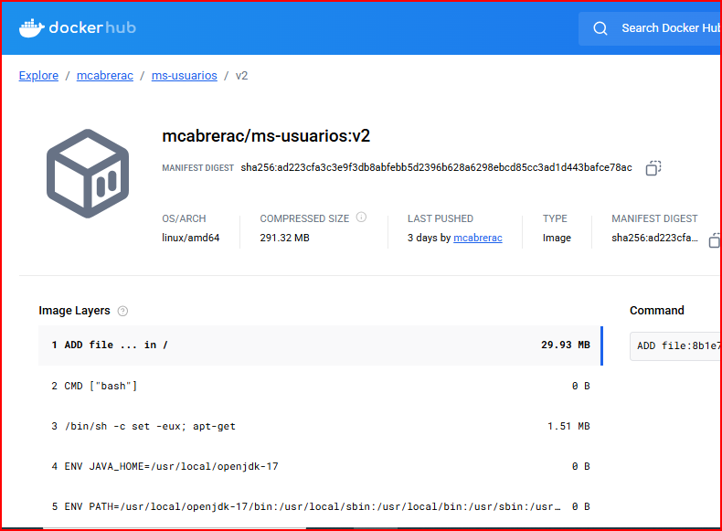

1. Imagen neuromotion-frontend

<https://hub.docker.com/layers/mcabrerac/neuromotion-frontend/v1/images/sha256-29a68221644546981fb69a0db5802f938190eebe845eeff9636037765c226d3d>

mcabrerac/neuromotion-frontend:v1

